March 13, 2004

Susan L.B. Jacobson, FASLA, President
American Society of Landscape Architects
636 Eye St., NW
Washington, DC 20001

Dear Susan,

It is my personal honor to nominate the Urban Land Institute to receive the 2004 Landscape Architecture Medal of Excellence.

For many years, this organization has been an important ally to ASLA in our efforts to improve land use planning, to encourage collaboration among developers, planners, designers, and public officials, and to promote the lasting value of landscape architecture throughout the nation.

A Brief History

The ULI was founded in 1936, when many American cities were experiencing both suburban expansion and urban decay, with limited public sector planning and no guidance available to the private sector. No organization existed in the country to research, analyze, or encourage responsible patterns for long-term urban growth, or to conduct inquiries into what constitutes sound real estate development projects and practices. These circumstances led Cincinnati real estate entrepreneur Walter Schmidt and six other prominent community builders to petition the National Association of Real Estate Boards (the forerunner of today’s National Association of Realtors) to establish a separate research institute within NAREB. This proved to be too limiting, and in 1940, ULI became a completely independent institute.

Born during the Great Depression, the ULI’s original objectives were very similar to its guiding principles today: to study and interpret real estate trends; to examine principles with which private enterprise could effectively develop real estate; to develop a body of knowledge in real estate and allied subjects; to publish informative texts and technical journals based on that knowledge; and to act as a statistical clearinghouse for the dissemination of real estate data.

Since its inception, ULI membership has grown from 230 members to some 18,000 professionals—including many leading landscape architects—in all 50 states and 52 countries around the world. It is a 501(c) (3) nonprofit research and education organization. The mission of the ULI is to provide responsible leadership in the use of land to enhance the total environment.
The members of the ULI are community builders, the people who plan, design, develop and redevelop neighborhoods, business districts and communities across the U.S. and around the world. Some 2,000 members are the CEOs, leading advisers, and policy-makers in the United States. Another 2,000 members are the leading owners, investors, and advisers in Europe, Japan, Australia, Canada, South Africa, South America, and Southeast Asia. More than 20 percent of ULI members work in government, academia, and public-private partnerships.

ULI members control, own, or enhance the value of more than 80 percent of the U.S. commercial property market. As the preeminent, multidisciplinary real estate forum, ULI facilitates the open exchange of ideas, information and experience among developers, planners, designers, and public officials dedicated to creating lasting value and great places. With pride, ULI members commit to the best in land use policy and practice through their Code of Ethics and professional conduct.

Land Use Research

ULI initiates cutting-edge research to anticipate emerging land use trends and issues, proposing creative solutions based on that research. The Institute’s continuing focus on nonpartisan research and education has made it one of the world’s most respected and quoted organizations in urban planning, land use, and development.

The cornerstone of ULI research are its case studies, which document best practices worldwide to impart cumulative knowledge to help the development community continuously improve its performance.

ULI collects objective data on key real estate segments and publishes it through America’s Real Estate, ULI Forecast, Emerging Trends, and Emerging Trends Europe.

Much of ULI’s amazing research is available on its Web site, www.uli.org.

Publications

The ULI bookstore currently carries more than 300 titles, almost all of which are applicable to the practice of landscape architecture. One of its most requested titles is the guide published in conjunction with ASLA in the early 1990s on the relationship between landscape design and property values (now out of print). ULI is presently in discussions with ASLA to update and republish this popular publication, supporting efforts of the ASLA Fund to study of the economic value of landscape architecture.

To share best practices, ULI publishes a number of magazines written by and for members, reporting on trends and innovations in land use development, bringing practical research and practitioner expertise to bear. Landscape architects regularly contribute to these publications, which are must-reads for every sector of the profession, from residential to commercial designers and planners to public practitioners.

Urban Land magazine covers development in all sectors—office, retail, industrial, residential, resort—throughout the world. Special editions are published in Europe and Japan.

Each quarter, the ULI publishes Multifamily Trends, reporting significant trends in affordable, market rate, luxury and seniors’ housing. Leonard Hopper, FASLA, chief landscape architect of the New York City Public Housing Authority, is contributing a feature article for the next issue of Multifamily Trends.

Special periodicals include Smart Growth News, Land Use Digest, Multifamily Developments, Housing News Roundup, Commercial News Roundup, Land Use Digest Europe, and many others.

Education

In addition to the annual conferences, professional development workshops, meetings, and symposia, ULI recognizes that the best education opportunities often take the form of idea exchanges among members. ULI sponsors both live and online Forums and Expert Panels to facilitate communication and advance of ideas on land use policy and development practice among its members and to the communities it serves around the country. Many leading landscape architects are regularly requested to serve on the roving Mayor’s Forums and Expert Panels that target key issues and problems facing cities and invite the best practices in to help assist them in reaching consensus of effective lasting solutions.

In addition to providing community support and professional education, ULI strives to teach students the importance of good land use policies and collaboration among the professions that direct land use policy. ULI’s University Education Program works to enhance the level of teaching for real estate and related education programs at the university level. The ULI Fellows Program was initiated in 1974 to serve as a bridge between the practicing development community and the academic community. Typically, 24 academics are designated a ULI Fellow annually and thus given recognition as well as special member benefits.
Fellows are appointed to represent various academic and professional disciplines from all regions of the country and are currently active in research or teaching functions at academic institutions or think tanks. They also must have achieved outstanding positions in their particular fields of expertise. ULI Fellows receive complimentary ULI full memberships and are expected to contribute actively to ULI events, programs, research, and educational activities.
Recognizing Best Practices

One of the ULI's guiding principles is that the achievement of excellence in land use practice should be recognized and rewarded. ULI consistently recruits leading landscape architects to serve on juries for its prestigious awards programs.

For 25 years, the ULI Awards for Excellence program has honored outstanding development projects throughout the world. With each award, the public becomes more keenly aware of the benefits of superior planning, design, and development, a goal ULI shares with ASLA. This year, ULI Europe has inaugurated its own Awards program. Winning projects and others are documented as case studies to share best practices.

The J.C. Nichols Prize for Visionary Urban Development is presented to an individual whose career or institution demonstrates the highest standards of responsible development. The very first recipient of the Nichols Prize was Mayor Joseph P. Riley, Honorary ASLA, for his firm dedication to maintaining the highest principles of urban design.

The annual ULI Gerald Hines Student Urban Design Competition connects the best and brightest across disciplines, providing students with collaborative tools to tackle a real world planning project. Joe Brown, FASLA, chairs the Hines Competition jury this year.

For the past couple of years the ASLA and ULI annual meetings have been held on the same dates in different cities, limiting our staff and leadership participation. This has inevitably diminished our official joint activities and information exchange. However, our mutual members have remained extremely active and vocal in both organizations and I am happy to know that this year our annual meeting dates do not conflict. Presenting the ULI with the Medal of Excellence will not only acknowledge the Institute’s important past achievements, but would also signify ASLA’s profound commitment to working in partnership with ULI in the future in ‘our collective’ mission “to provide responsible leadership in the wise use of land to enhance and sustain the total environment.”

I strongly encourage the Executive Committee and the Board of Trustees to recognize the URBAN LAND INSTITUTE for its significant contributions to landscape architecture policy, research, education, project planning and design.

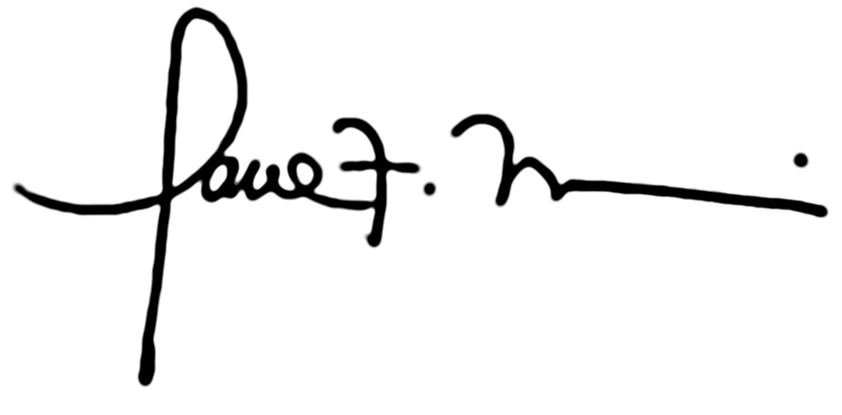
Sincerely,

Paul F. Morris, FASLA
ASLA Immediate Past President

