Paul Schell
5655 S. Winterwood Road, Langley, WA 98260-8256
pschell@langleywa.com 360-341-1037

Rodney L. Swink, FASLA
Chair, Honors and Awards Advisory Committee
American Society of Landscape Architects
636 Eye Street NW
Washington DC 20001 March 16, 2004

Dear Mr. Swink,

Please accept this letter as a recommendation for Virginia Anderson for the ASLA LaGasse Medal. I have worked closely with Virginia, and count her as a dear friend and colleague, for more than 25 years.

Her accomplishments date well beyond her present position as Director of Seattle Center, for which she is now being nominated for this award. Virginia is an outstanding public servant; indeed, she is the very definition of the term. She is an urban person, raised in the poorest of neighborhoods in South Chicago and who found her own value as a child in the few, beautiful public spaces in which she felt welcomed. Translating that value into a right for others, Virginia has long worked to meld architecture, open space and the very way people use public places as the pattern to enrich our communities and bring diverse people together. At a time of civic cynicism in our nation, she is a ray of light that offers inspiration and motivation.

A visionary, she has transformed a once seedy Worlds Fair site into the most popular gathering place on the West Coast. I believe 10 million people annually make the trek to Seattle Center, enjoying its many fountains, green spaces, public art, beautiful buildings, and programs and activities offered there.

Prior to her work there (which she has led through four mayoral administrations including my own), she worked as Senior Vice President at Cornerstone Development where she led my company’s efforts to clean up Tacoma, beautify Seattle’s Pike Place Market, and build affordable urban housing through a non profit that she helped create.

Virginia is a remarkable, unique woman whose leadership is instantly recognized by those who meet her. She is honest, believable, trustworthy, and intelligent. She keeps the goal in sight, and doesn’t bend to popular ideology. Virginia keeps the long term public stewardship of our public spaces—Seattle Center—in mind, and yet is able to create progress that is visible and real in the short term. She is an excellent candidate for this award, and I thank you for considering her.

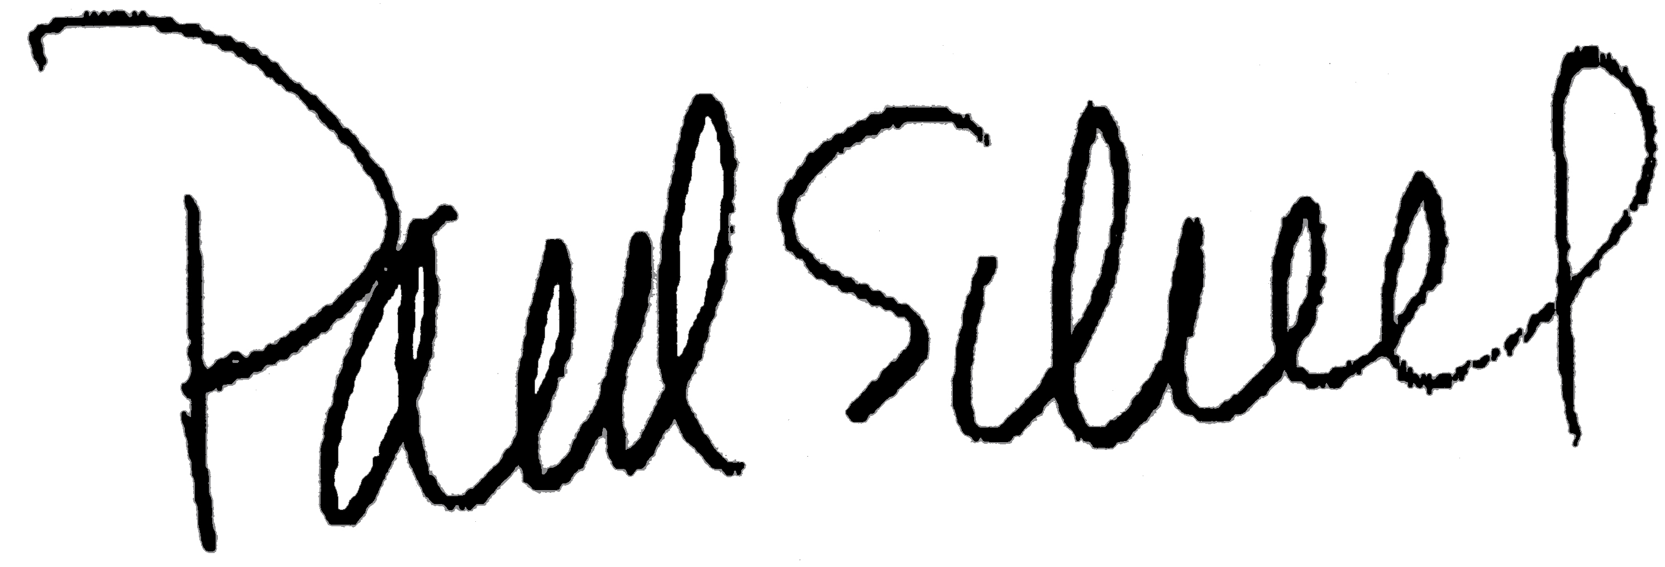
Very truly yours,

Paul Schell

