LICENSURE
2011 ASLA Award Winner
The Steel Yard, Providence, RI
Image: Christian Phillips Photography
What Landscape Architects Do DDo andscape Architects Do

Landscape architects plan livable communities that foster active lifestyles, design green streets that manage stormwater runoff, plan cutting-edge transportation corridors that are safe for all users, and help communities prepare for and recover from natural disasters. Landscape architecture encompasses the analysis, planning, design, management, and stewardship of the natural and built environment through science and design. Well-known examples include Central Park in New York City, the grounds of the U.S. Capitol in Washington, D.C., the Oklahoma City National Memorial, and Chicago’s Millennium Park. Landscape architecture includes both iconic and neighborhood places, including commercial developments, downtown streetscapes, green roofs, local parks, and residential communities.

Fundamentally, the practice of landscape architecture should keep the public safe from hazards, protect and maximize natural resources, and prevent damage to public or private property from changes in the built environment. Landscape architects should provide stormwater solutions that effectively manage water to
minimize runoff, improve water quality, control erosion, and eliminate safety hazards from standing water/ice. Landscape architects should
design a site—whether a playground, streetscape, campus, or park—that safely coordinates all uses of a site to avoid injuries and reduces the threat of crime. Landscape architecture should ensure roads, parking lots, medians and other transportation elements safeguard driver and pedestrian safety, are ADA accessible, and also provide environmental and community benefits.

The only way to make sure that landscape architects protect the public in these ways is to license landscape architects. The education, experience, and examination required to earn licensure provides a guarantee that the individual has demonstrated competency in all of the areas that impact the public health, safety, and welfare.
Licensure Protects Your Community

States and localities recognize the dangers to the public from the built environment. This is evident not only through licensing, but through building codes and ordinances related to water, landscape, and other aspects that can pose a threat to the health and safety of our communities. These codes typically demonstrate the public
trust of these communities in licensed professionals, requiring a licensee to oversee and stamp public and private projects that require public approval.

Excluding landscape architects from this system only serves to limit expertise and stifle competition for this industry. In the end, less competition means higher fees for these services. Errors and omissions insurance typically requires a license to qualif for coverage, making sure licensees are adequately able to take responsibility for any legal liability.
Licensure Protects Clients and Fosters Competition

asla.org/advocacy

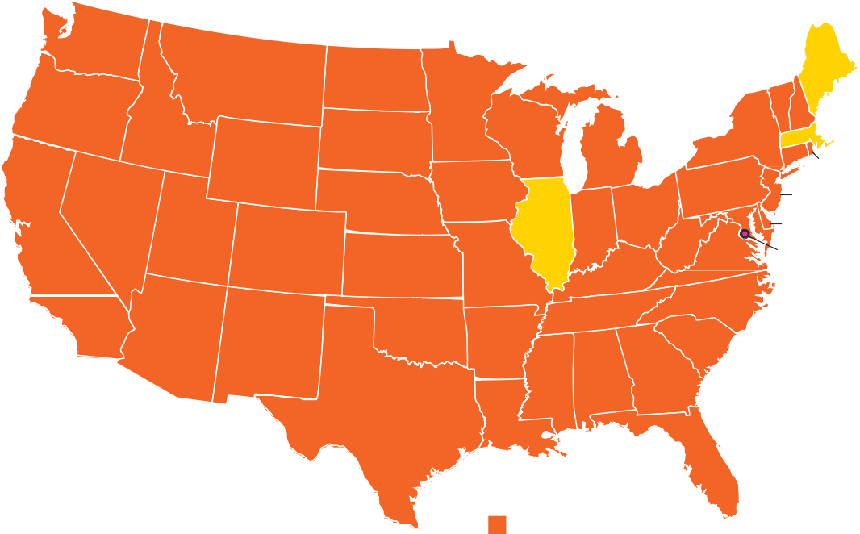
WA
AK
ME
MT
ND
OR
MN
ID
SD
WI
VT NH
NY MA CT
WY
MI
RI
IA
PA
NE
NJ
LICENSURE
NV
OH
MD
DE
UT
IL
IN
CA
WV
CO
VA
DC*
KS MO
KY
NC
TN
AZ
OK
NM
AR
SC
HI
MS
AL
GA
TX
LA
Facts and Figures
FL
All 50 states have recognized that regulation of landscape
Practice Act (47)
Title Act (3)

architecture is necessary to protect the public health, safety,
and welfare. All but three states regulate the profession through a practice act, which requires a license to practice the profession
and use the title ‘landscape architect’. The remaining three states have enacted title act statutes, which is a weaker form of regulation that allows anyone to practice landscape architecture if they call it something else.

A practice act is important because of the real danger to clients and the users of these public and private spaces: physical injury; property damage; and financial ruin.

States typically follow the three-step process to earn licensure common among the design professions: education, experience, and examination.

EDUCATION

Most landscape architects have an accredited degree in landscape architecture. The Landscape Architectural Accreditation Board
(LAAB) accredits bachelor- and master-level programs at 68 institutions across the United States.

EXPERIENCE

Most states require that landscape architects have 2–4 years

* DC does not regulate landscape architecture

experience under a licensed landscape architect in that state. Many states provide some flexibility for educational background, allowing candidates with more years of experience to qualify without an accredited degree, reducing barriers to entry into the profession.

EXAMINATION

All states require every candidate to pass the four-part Landscape Architect Registration Examination (LARE). While education and experience standards ensure each candidate has been prepared to enter the profession, the LARE provides a definitive measure of competence to ensure each landscape architect will protect the public health, safety, and welfare.

Skills tested include: project development; site suitability; stormwater management; erosion control; hydrology; and irrigation. Candidates also must demonstrate competence in such areas as: layout of playground equipment; vehicular and pedestrian circulation; roadway alignment design; site lighting layouts; manipulation of contours
and spot elevations; calculations of slopes, grades, and volumes of material; design of surface and subsurface storm drainage, including hydraulic characteristics and storm drain connections; and site planning for buildings.
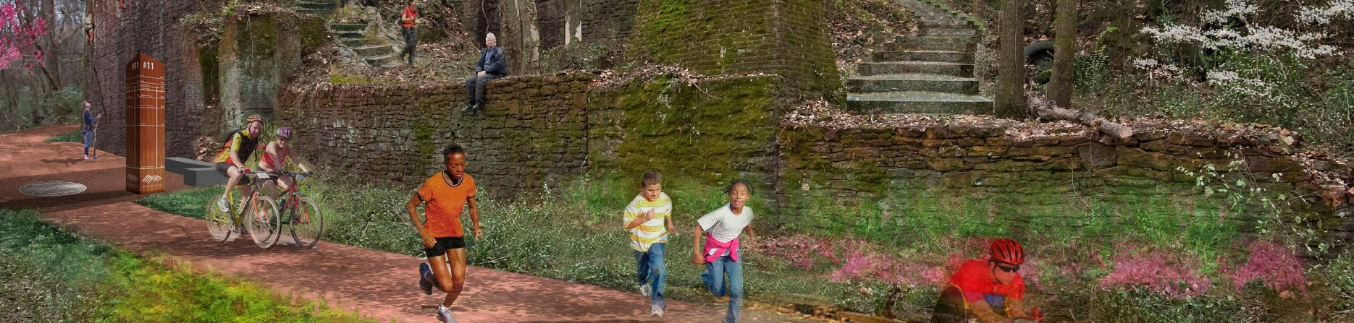
We urge your support of legislation that provides effective regulation of the practice of landscape
architecture. Licensure ensures that only capable, trained professionals are performing landscape architecture work that impacts the public health, safety, and welfare.
asla.org/advocacy
2012 ASLA Award Winner
Red Mountain Park, Birmingham, AL
Image: Wallace Roberts & Todd, LLC
Support Licensure

